Low-pass filter:
$$Y\left(z\right)=Y\left(z−1\right)+α\left(U\left(z\right)−Y\left(z−1\right)\right)$$
$$=\left(1−α\right)Y\left(z−1\right)+αU\left(z\right)$$
$$=\left(1−α\right)z^{−1}Y\left(z\right)+αU\left(z\right)$$

$$\frac{Y\left(z\right)}{U\left(z\right)}=\frac{α}{1−\left(1−α\right)z^{−1}}=\frac{αz}{z−\left(1−α\right)}$$
$$f\left(t\right)=Z^{−1}\left[\frac{Y\left(z\right)}{U\left(z\right)}\right]=αe^{−βt}, e^{−aT}=\left(1−α\right)$$
$$ℒ\left[f\left(t\right)\right]=\frac{α}{s+β}=\frac{α/β}{s/β+1}$$
In our instance:
$$e^{−aT}=0.99, T=0.05,α=0.01$$
$$ℒ\left[f\left(t\right)\right]=\frac{α/β}{s/β+1}≈\frac{0.05}{5s+1}$$

complementary filter:
In keep a good attidude, equation (50):
we can multiply $q_{t}$ in both side of this equation.
$$q_{est}=\left(1−α\right)q_{t}+αq_{t}∆q_{acc}$$
This is the same expression in madgwick:
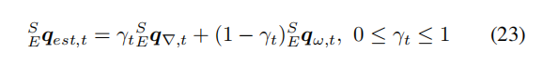
Now, lets analysis, damn how it works!
Reference system block diagram in madgwick:
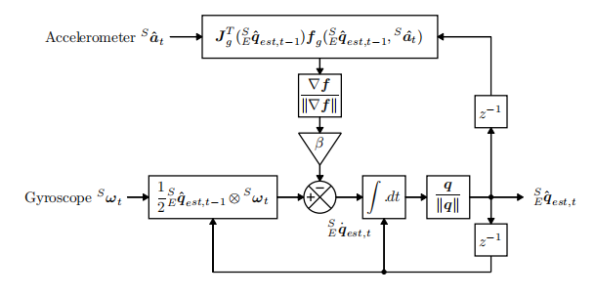
Notice that the comparision point is the derivation of euqation (23), and change the graph from z region to s region.
We can abstract it into following diagram:
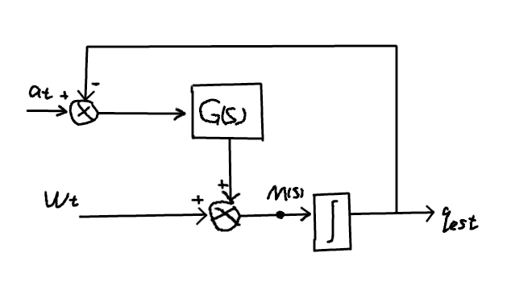
We can write out the transform function in point M:
$$s×q\left(s\right)=G\left(s\right)\left(a\left(s\right)−q\left(s\right)\right)+ω\left(s\right)$$
$$q\left(s\right)=\frac{G\left(s\right)}{G\left(s\right)+s}a\left(s\right)+\frac{1}{G\left(s\right)+s}ω\left(s\right)$$
$$q\left(s\right)=\frac{G\left(s\right)}{G\left(s\right)+s}a\left(s\right)+\frac{s}{G\left(s\right)+s}×\frac{1}{s}×ω\left(s\right)$$
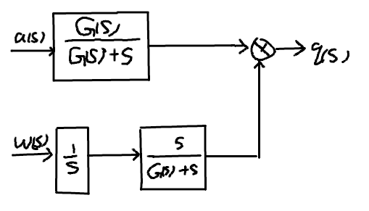
Therefore, the system can be write into a open loop system:

$\frac{G\left(s\right)}{G\left(s\right)+s}$ is LPF.
$\frac{s}{G\left(s\right)+s}$ is HPF.
The complementary is a bandpass filter.

